## 1. Verify That You Have Java

First, check if you have the Java Developer Kit, version 7 or greater already installed. To check if you have JDK installed (and which version), open a terminal window and type: java -version and hit enter.

The example below shows Java version 8.0_05 -- the version number comes after the “1.”

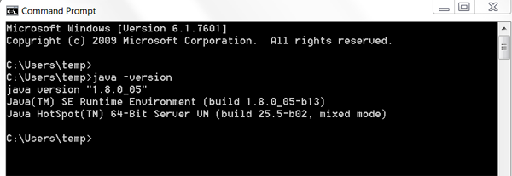

If you have Java 7 or greater, you computer is set up!

If the JDK is **not** available, or the version is lower than 7, go on to Step 2 below.

**2. Download the Java Development Kit**

Download the Java Development Kit, aka, the JDK, from [this page](http://www.oracle.com/technetwork/java/javase/downloads/index.html).

Oracle, the company that maintains Java, has a lot of options and acronyms. We're looking for the plain old JDK. This is the kit you need to start developing your apps with Java.

As of May 2015, the download icon for the JDK looked like this:

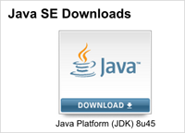

After you click the download link, you'll see a list of options for download. Go to the **Java SE Development Kit** menu of options. Do not go to the demos and samples (the menus look very similar, so make sure to read the heading at the top).

**Install**

You've got a lot of options here, but the two you care about are the Windows options.

If your computer is only a few years old, you're most likely going to download the 64-bit option. If your computer is a little older you can [follow these instructions](https://support.microsoft.com/en-us/kb/827218) to double check.

I'm going to download the 64-bit option (highlighted below).

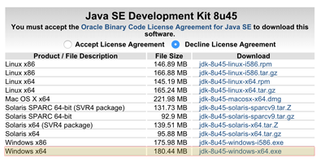

Accept the license agreement, and download it. Once you've downloaded it, go ahead and double click it to install.

**3. Verify That You Have Java**

Go back to Step 1 and confirm that you have Java version 7 or higher installed.

**Do not move on with Android Studio install until after you have installed the JDK**. Without a working copy of Java, the rest of the process will not work. If you can't get the download to work, look for error messages, and try googling to find a solution.

[Link to Java download site](http://www.oracle.com/technetwork/java/javase/downloads/index.html)

# Installing the Java Development Kit: Mac Guide

## 1. Verify That You Have Java

First, check if you have the Java Developer Kit, version 7 or greater already installed. To check if you have JDK installed (and which version), open a terminal window and type: java -version and hit enter.

The example below shows Java version 8.0_45 -- the version number comes after the “1.”

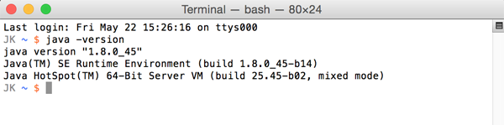

If you have Java 7 or greater, you computer is set up!

If the JDK is **not** available, or the version is lower than 7, go on to Step 2 below.

## 2. Download the Java Development Kit

Download the Java Development Kit, aka, the JDK, from [this page](http://www.oracle.com/technetwork/java/javase/downloads/index.html).

Oracle, the company that maintains Java, has a lot of options and acronyms. We're looking for the plain old JDK. This is the kit you need to start developing your apps with Java.

As of May 2015, the download icon for the JDK looked like this:



After you click the download link, you'll see a list of options for download. Go to the **Java SE Development Kit** menu of options.

Do not go to the demos and samples (the menus look very similar, so make sure to read the heading at the top).

### Install

Select the JDK for your operating system (Mac OSX). In most cases, if you have a machine that is less than 4 years old, you should choose the **x64** (64-bit) version (highlighted below). Search online for instructions if you have an older machine and are unsure what version to download.

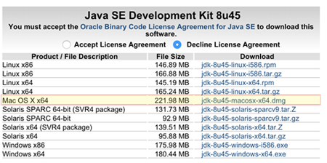

Accept the license agreement to download and locate the file, and double click it to begin the installation process.

## 3: Verify That You Have Java

Go back to Step 1 and confirm that you have Java version 7 or higher installed.

**Do not move on with Android Studio install until after you have installed the JDK**. Without a working copy of Java, the rest of the process will not work. If you can't get the download to work, look for error messages, and try googling to find a solution.

# Windows: Guide to Install Android Studio

* Note 1: Install JDK before you proceed for installing Android Studio IDE.
* Note 2: For instructions to install Android Studio in Mac OS, go to [this page](https://classroom.udacity.com/courses/ud837/lessons/4034888704/concepts/42729843130923).
* Note 3: Appearance of the installation wizard may change over time. However, the installation steps would remain the same.

## Step 1. Download Android Studio

Navigate to the [Android developers' site](https://developer.android.com/studio?utm_campaign=android_basics&utm_medium=course&utm_source=udacity). This page will automatically detect your operating system. Click on the "DOWNLOAD ANDROID STUDIO" button.

[[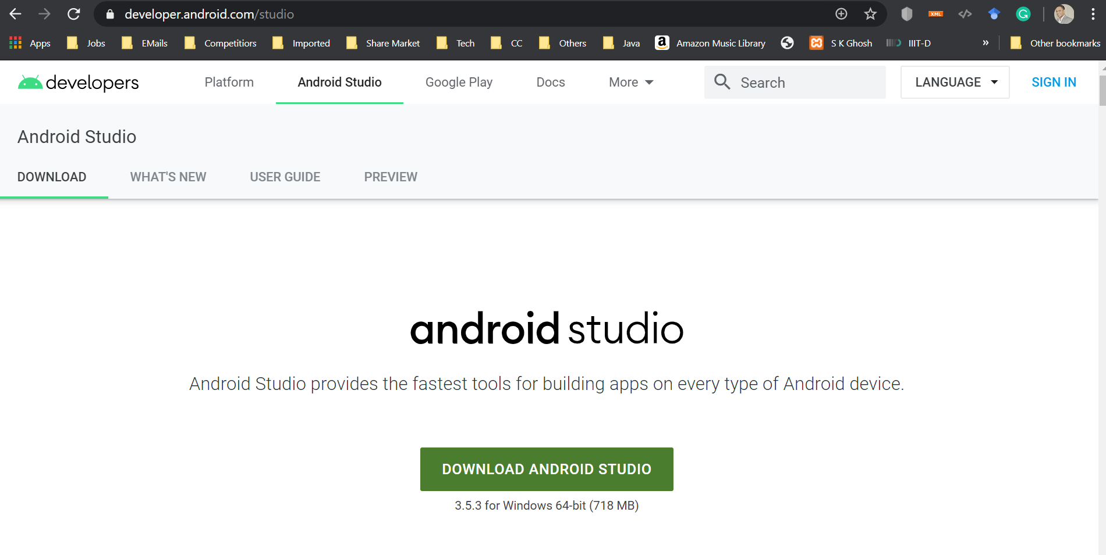](https://classroom.udacity.com/courses/ud808/lessons/4216368924/concepts/43001585890923)](https://classroom.udacity.com/courses/ud808/lessons/4216368924/concepts/43001585890923)

It will open up the **Terms and Conditions** pop-up. Select the checkbox that says "I have read and agree with the above terms and conditions" and click the “DOWNLOAD ANDROID STUDIO FOR WINDOWS” button to start the download.

[[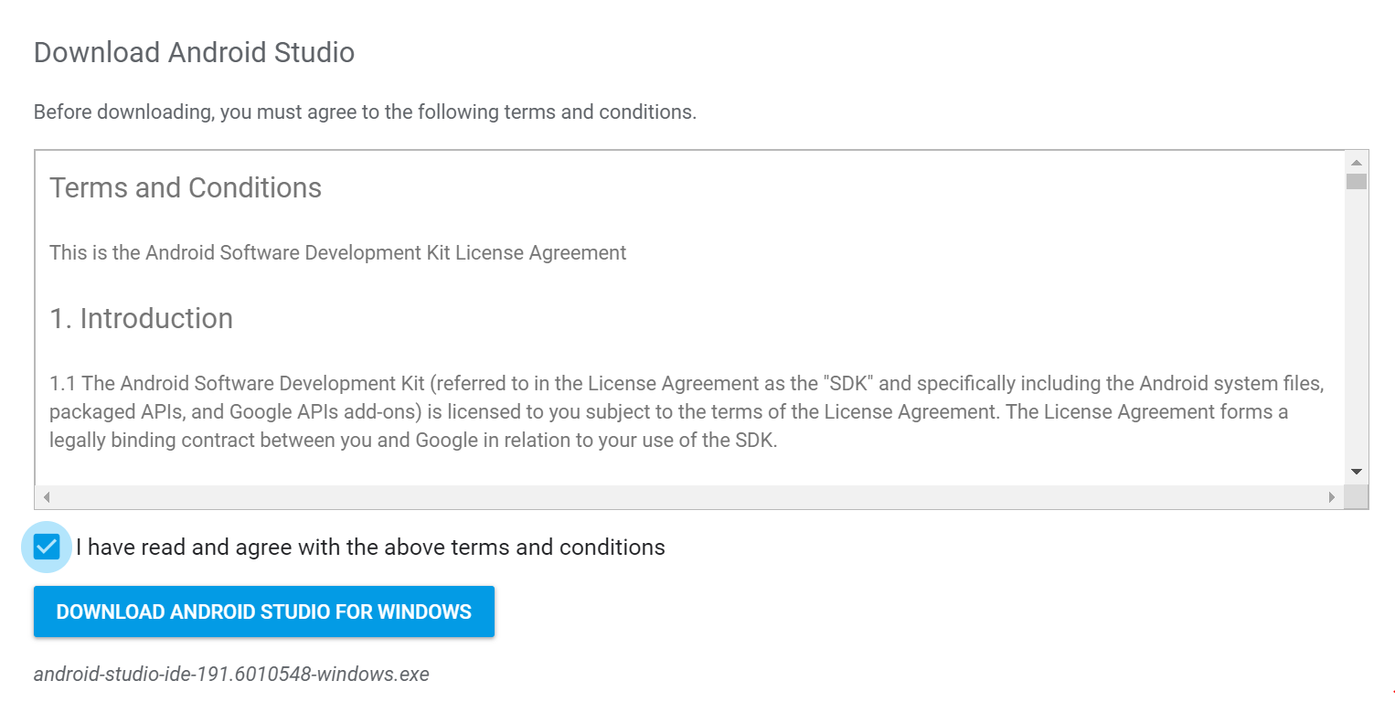](https://classroom.udacity.com/courses/ud808/lessons/4216368924/concepts/43001585890923)](https://classroom.udacity.com/courses/ud808/lessons/4216368924/concepts/43001585890923)

## Step 2. Install Android Studio

Right-click the downloaded **.exe** file and select to Run as Administrator. It will start the Android Studio installation wizard as follows:

[[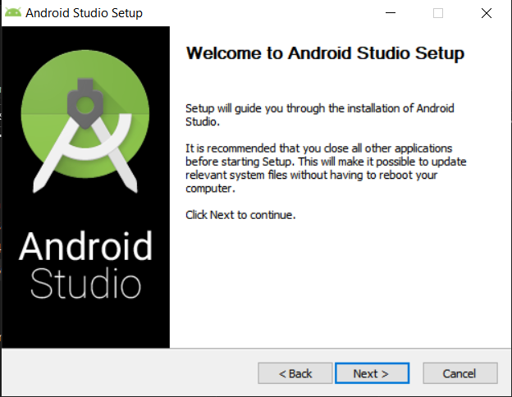](https://classroom.udacity.com/courses/ud808/lessons/4216368924/concepts/43001585890923)](https://classroom.udacity.com/courses/ud808/lessons/4216368924/concepts/43001585890923)

You need to follow the prompts and accept the default for all steps. In the next window, choose all the components to be installed:

[[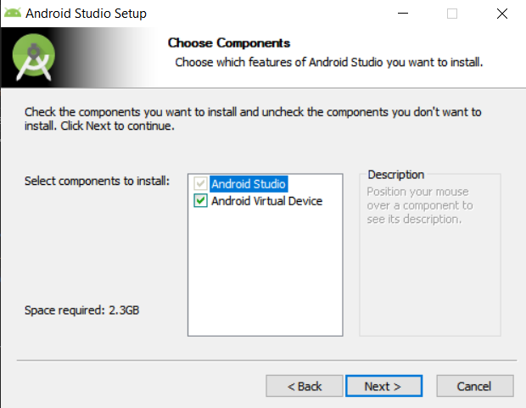](https://classroom.udacity.com/courses/ud808/lessons/4216368924/concepts/43001585890923)](https://classroom.udacity.com/courses/ud808/lessons/4216368924/concepts/43001585890923)

Select the default configuration settings:

[[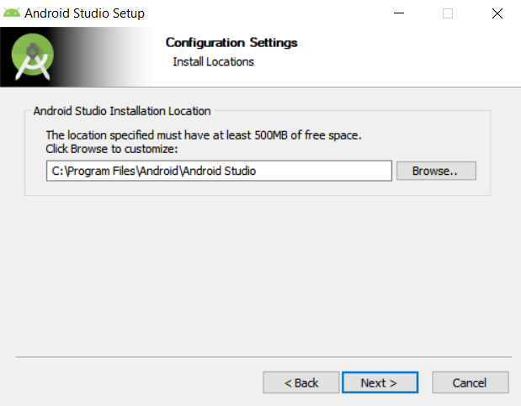](https://classroom.udacity.com/courses/ud808/lessons/4216368924/concepts/43001585890923)](https://classroom.udacity.com/courses/ud808/lessons/4216368924/concepts/43001585890923)

Select the default start menu:

[[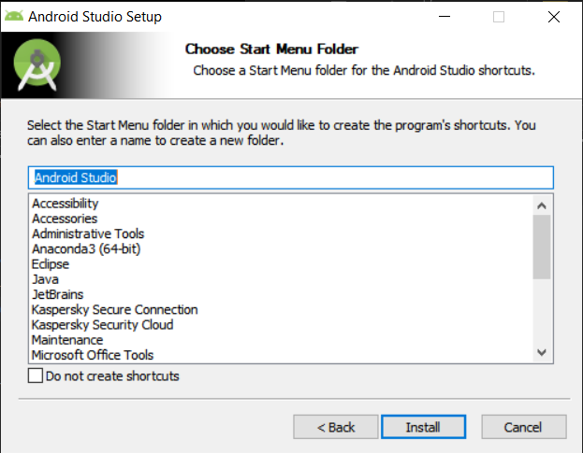](https://classroom.udacity.com/courses/ud808/lessons/4216368924/concepts/43001585890923)](https://classroom.udacity.com/courses/ud808/lessons/4216368924/concepts/43001585890923)

The installation wizard will download some additional components. This step might take some time depending on your internet speed.

[[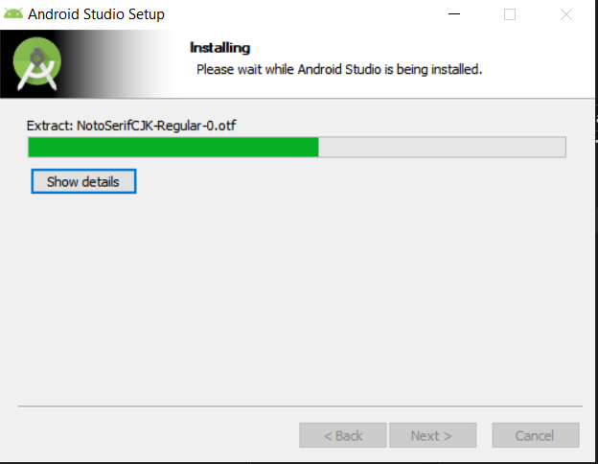](https://classroom.udacity.com/courses/ud808/lessons/4216368924/concepts/43001585890923)](https://classroom.udacity.com/courses/ud808/lessons/4216368924/concepts/43001585890923)

The following window would confirm the successful download of all the necessary components. Click on the “Finish” button.

[[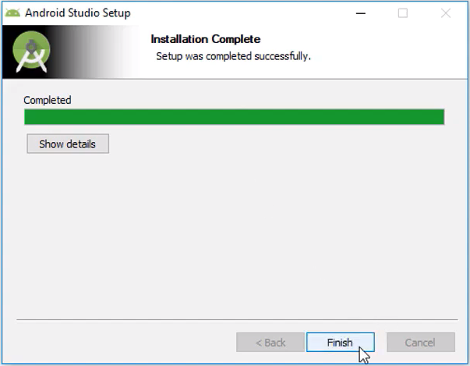](https://classroom.udacity.com/courses/ud808/lessons/4216368924/concepts/43001585890923)](https://classroom.udacity.com/courses/ud808/lessons/4216368924/concepts/43001585890923)

The following window would confirm the successful installation:

[[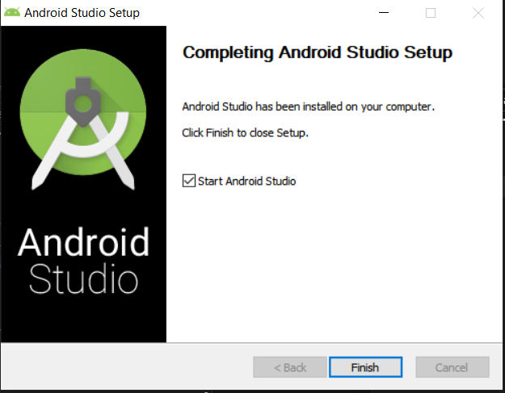](https://classroom.udacity.com/courses/ud808/lessons/4216368924/concepts/43001585890923)](https://classroom.udacity.com/courses/ud808/lessons/4216368924/concepts/43001585890923)

You need to select the **"Start Android Studio"** checkbox, which will open up the Android Studio application that just got installed on your computer. Next, the **Setup** wizard would follow.

## Step 3. Android Studio Setup Wizard

This wizard will set up Android Studio for you for the first time usage. Proceed with default prompts.

[[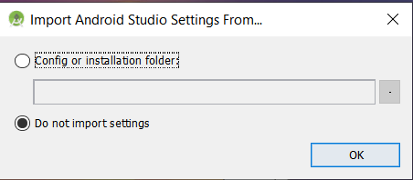](https://classroom.udacity.com/courses/ud808/lessons/4216368924/concepts/43001585890923)](https://classroom.udacity.com/courses/ud808/lessons/4216368924/concepts/43001585890923)

Next, it would take your preferences for installation type and theme. Choose the **"Standard"** as an installation type.

[[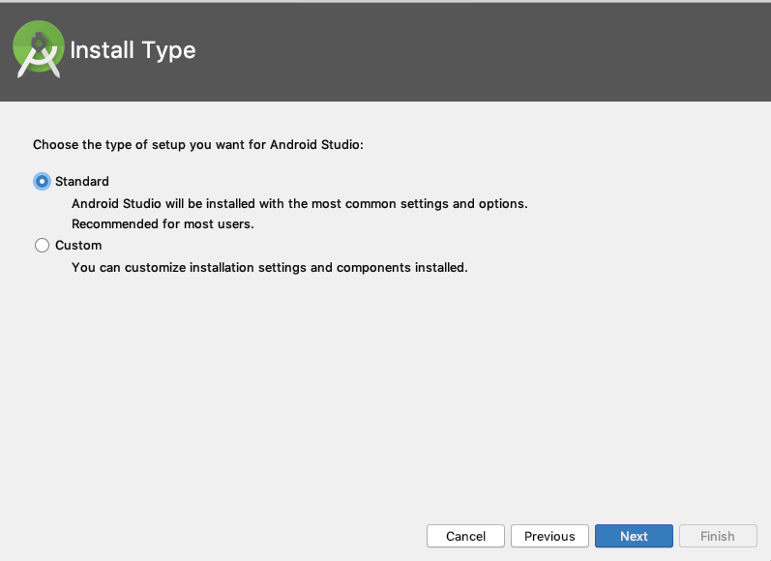](https://classroom.udacity.com/courses/ud808/lessons/4216368924/concepts/43001585890923)](https://classroom.udacity.com/courses/ud808/lessons/4216368924/concepts/43001585890923)

Select the desirable theme - **Darcula** (Dark) or **Light** and proceed with prompts.

# Mac: Guide to Install Android Studio

* Note 1: Install JDK before you proceed for installing Android Studio IDE.
* Note 2: For Instructions to install Android Studio in Windows OS, go to [this page](https://classroom.udacity.com/courses/ud837/lessons/4034888704/concepts/43001585890923).
* Note 3: Appearance of the installation wizard may change over time. However, the installation steps would remain the same.

## Step 1. Download Android Studio

Navigate to the [Android developer’s site](https://developer.android.com/studio?utm_campaign=android_basics&utm_medium=course&utm_source=udacity). This page will automatically detect your operating system. Click on the "DOWNLOAD ANDROID STUDIO" button.

[[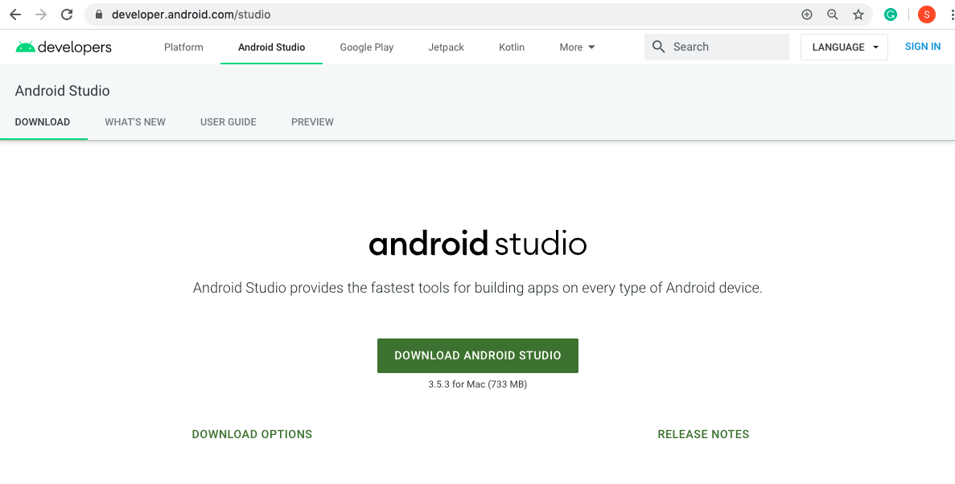](https://classroom.udacity.com/courses/ud808/lessons/4216368924/concepts/42729843130923)](https://classroom.udacity.com/courses/ud808/lessons/4216368924/concepts/42729843130923)

It will open up the **Terms and Conditions** pop-up. Select the checkbox that says "I have read and agree with the above terms and conditions" and click the “DOWNLOAD ANDROID STUDIO FOR MAC” button to start the download.

[[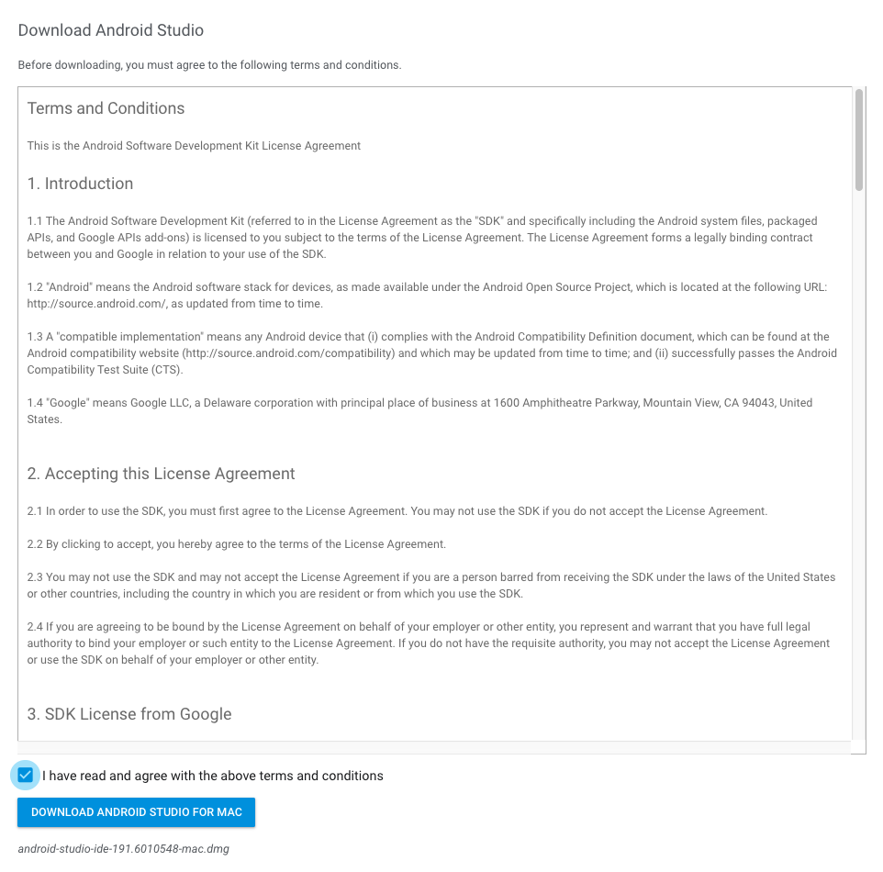](https://classroom.udacity.com/courses/ud808/lessons/4216368924/concepts/42729843130923)](https://classroom.udacity.com/courses/ud808/lessons/4216368924/concepts/42729843130923)

## Step 2. Install Android Studio

Double-click the downloaded **.dmg** file and proceed with the default prompt.

[[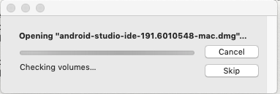](https://classroom.udacity.com/courses/ud808/lessons/4216368924/concepts/42729843130923)](https://classroom.udacity.com/courses/ud808/lessons/4216368924/concepts/42729843130923)

Drag the Android Studio icon into your **"Applications"** folder.

[[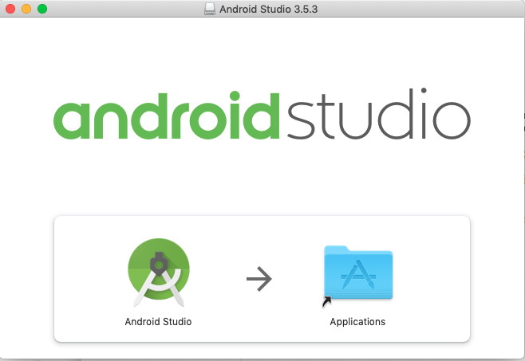](https://classroom.udacity.com/courses/ud808/lessons/4216368924/concepts/42729843130923)](https://classroom.udacity.com/courses/ud808/lessons/4216368924/concepts/42729843130923)

It would take while to copy into the **"Applications"** folder:

[[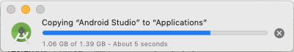](https://classroom.udacity.com/courses/ud808/lessons/4216368924/concepts/42729843130923)](https://classroom.udacity.com/courses/ud808/lessons/4216368924/concepts/42729843130923)

## Step 3. Android Studio Setup Wizard

Open the Android Studio application that just got installed on your computer. It will open up a wizard to set up Android Studio for you for the first time usage.

[[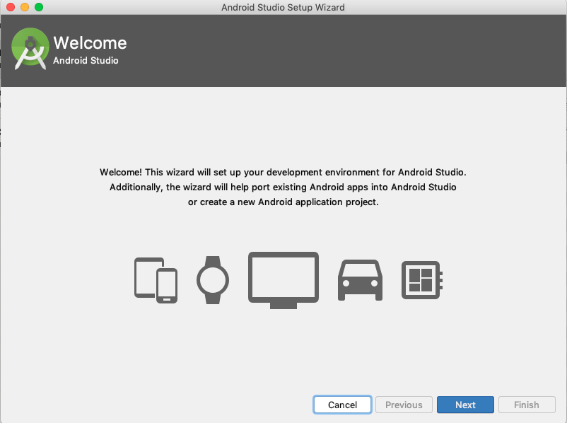](https://classroom.udacity.com/courses/ud808/lessons/4216368924/concepts/42729843130923)](https://classroom.udacity.com/courses/ud808/lessons/4216368924/concepts/42729843130923)

Next, it would take your preferences for installation type and theme. Choose the **Standard** as an installation type.

[[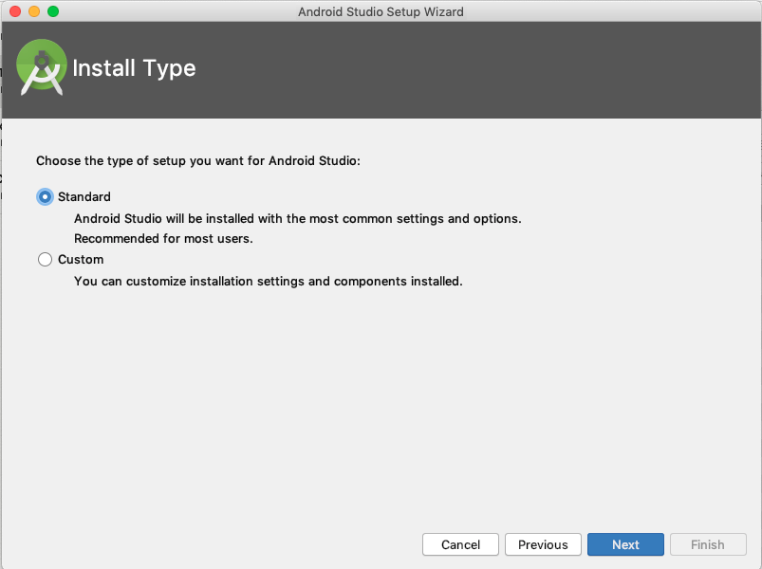](https://classroom.udacity.com/courses/ud808/lessons/4216368924/concepts/42729843130923)](https://classroom.udacity.com/courses/ud808/lessons/4216368924/concepts/42729843130923)

Select the desirable theme - **Darcula** (Dark) or **Light** and proceed with the default prompt.

[[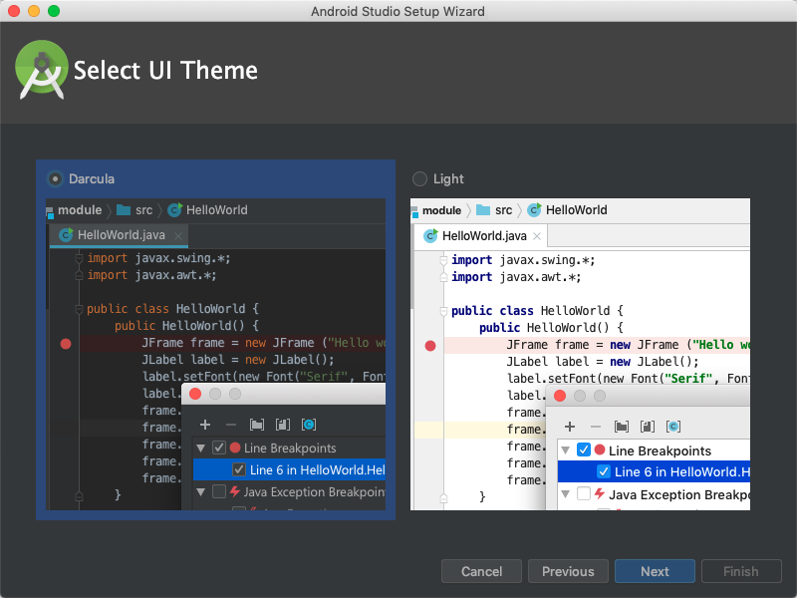](https://classroom.udacity.com/courses/ud808/lessons/4216368924/concepts/42729843130923)](https://classroom.udacity.com/courses/ud808/lessons/4216368924/concepts/42729843130923)

When you are finished, you would see the following screen:

[[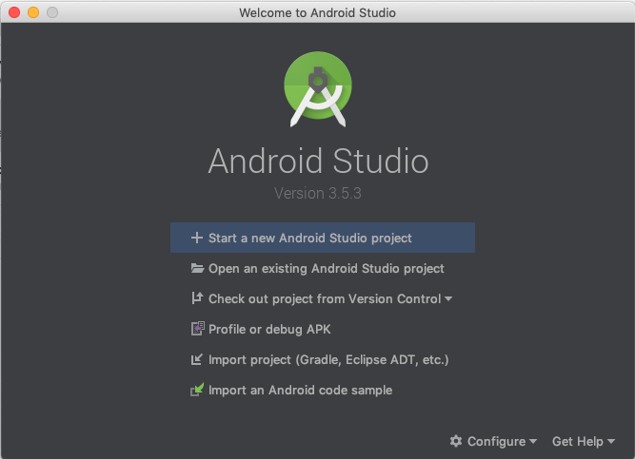](https://classroom.udacity.com/courses/ud808/lessons/4216368924/concepts/42729843130923)](https://classroom.udacity.com/courses/ud808/lessons/4216368924/concepts/42729843130923)

You may proceed to **"Start a new Android Studio project"**.

## Step 4: Start a Project

If you start a new project, it would ask you to choose from a set of templates, as follows:

[[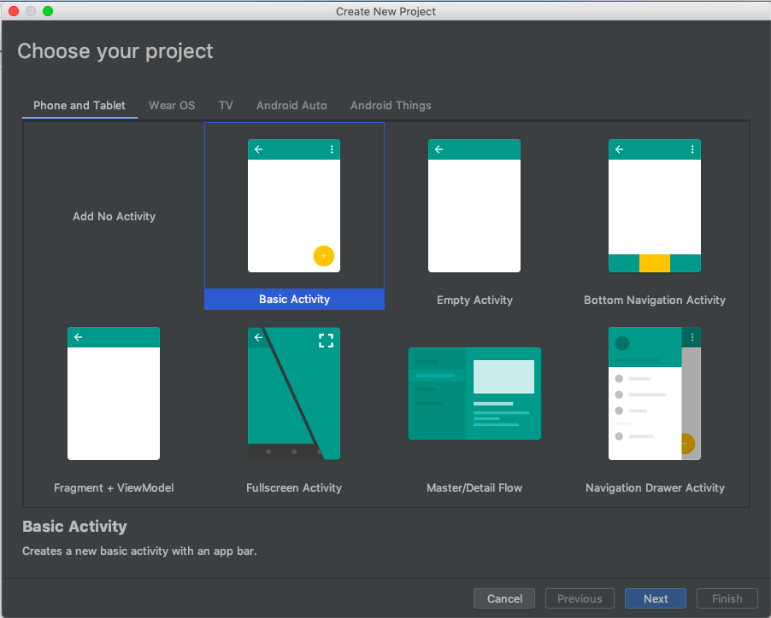](https://classroom.udacity.com/courses/ud808/lessons/4216368924/concepts/42729843130923)](https://classroom.udacity.com/courses/ud808/lessons/4216368924/concepts/42729843130923)

For this example, we chose the **“Basic Activity”** template. Enter the necessary project-specific information such as Project Name, Package, Location (path), and Language in the next screen:

[[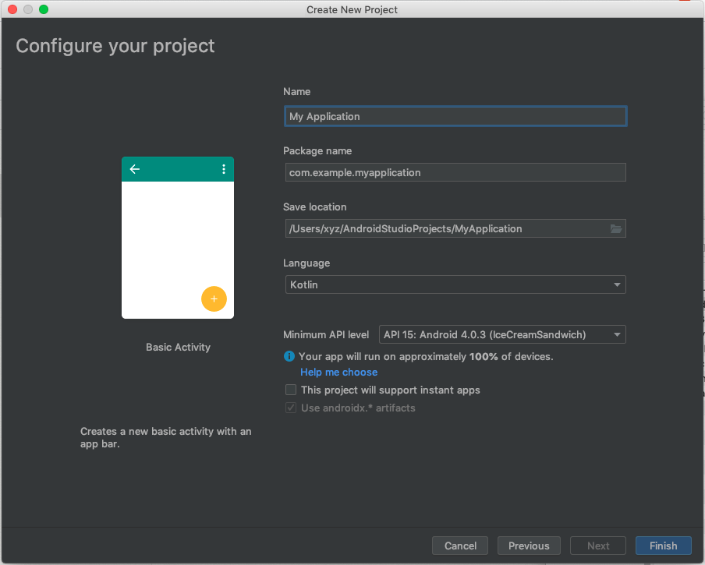](https://classroom.udacity.com/courses/ud808/lessons/4216368924/concepts/42729843130923)](https://classroom.udacity.com/courses/ud808/lessons/4216368924/concepts/42729843130923)

Following is the snapshot of the successfully installed IDE. You may choose to update the IDE and Plugins if prompted.

[[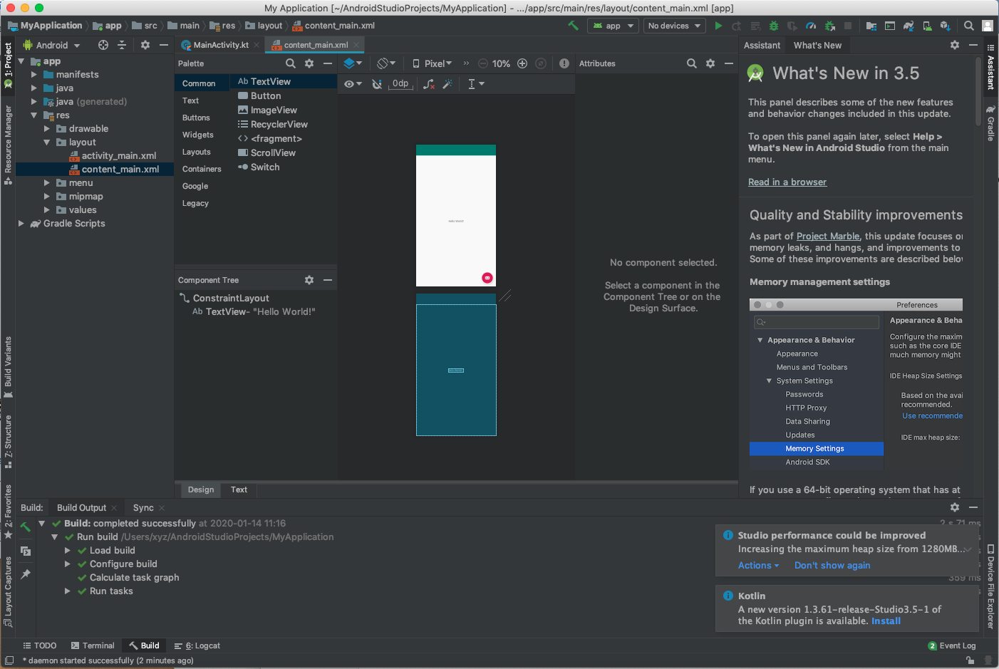](https://classroom.udacity.com/courses/ud808/lessons/4216368924/concepts/42729843130923)](https://classroom.udacity.com/courses/ud808/lessons/4216368924/concepts/42729843130923)

You are all set to develop Apps in Android Studio.

[[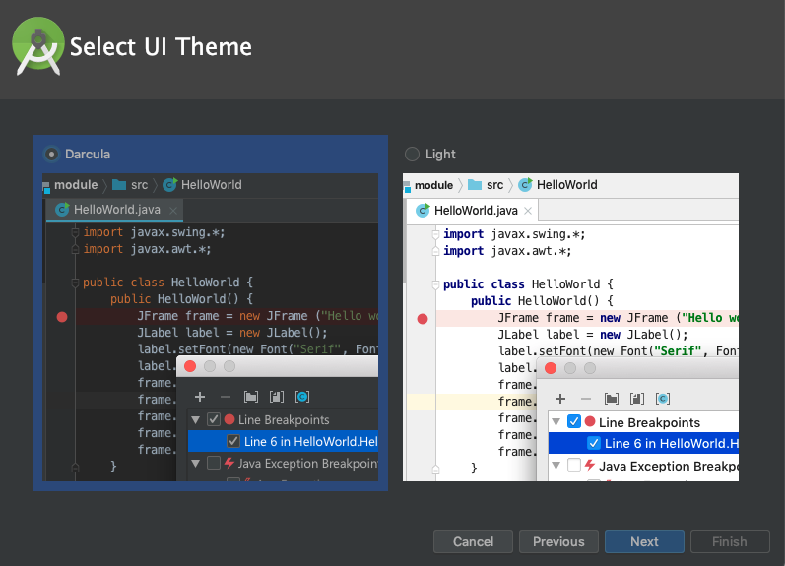](https://classroom.udacity.com/courses/ud808/lessons/4216368924/concepts/43001585890923)](https://classroom.udacity.com/courses/ud808/lessons/4216368924/concepts/43001585890923)

It will download a few more components, as shown below:

[[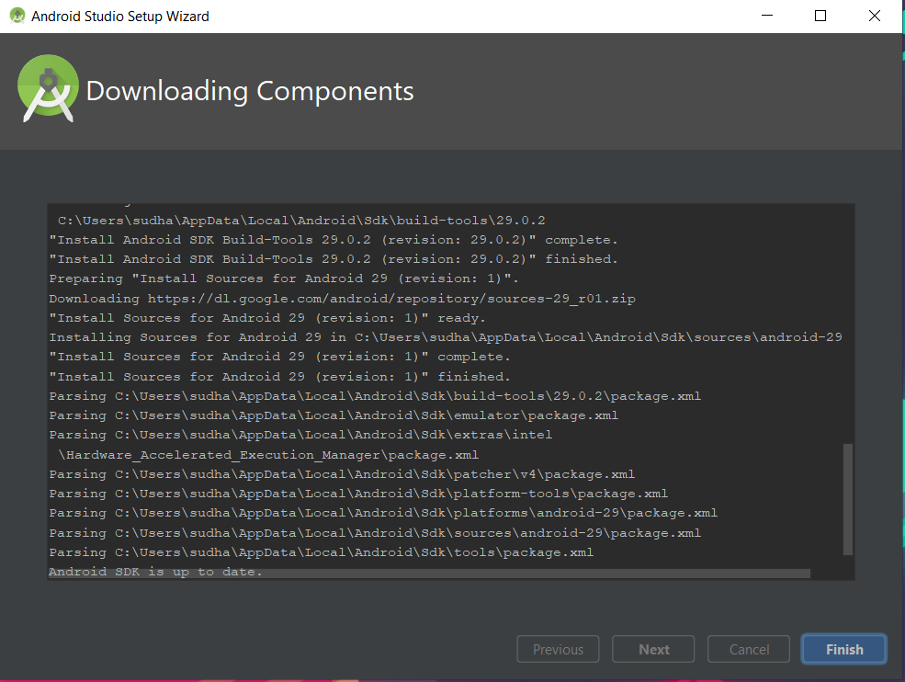](https://classroom.udacity.com/courses/ud808/lessons/4216368924/concepts/43001585890923)](https://classroom.udacity.com/courses/ud808/lessons/4216368924/concepts/43001585890923)

When you are finished, you will see this window:

[[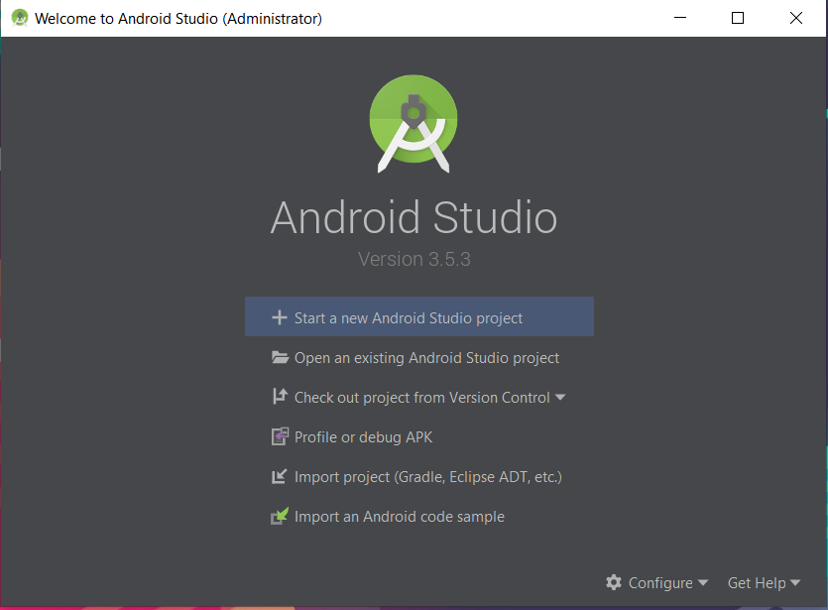](https://classroom.udacity.com/courses/ud808/lessons/4216368924/concepts/43001585890923)](https://classroom.udacity.com/courses/ud808/lessons/4216368924/concepts/43001585890923)

You may proceed to **"Start a new Android Studio project"**.

## Step 4: Start a Project

If you start a new project, it would ask you to choose from a set of templates, as follows:

[[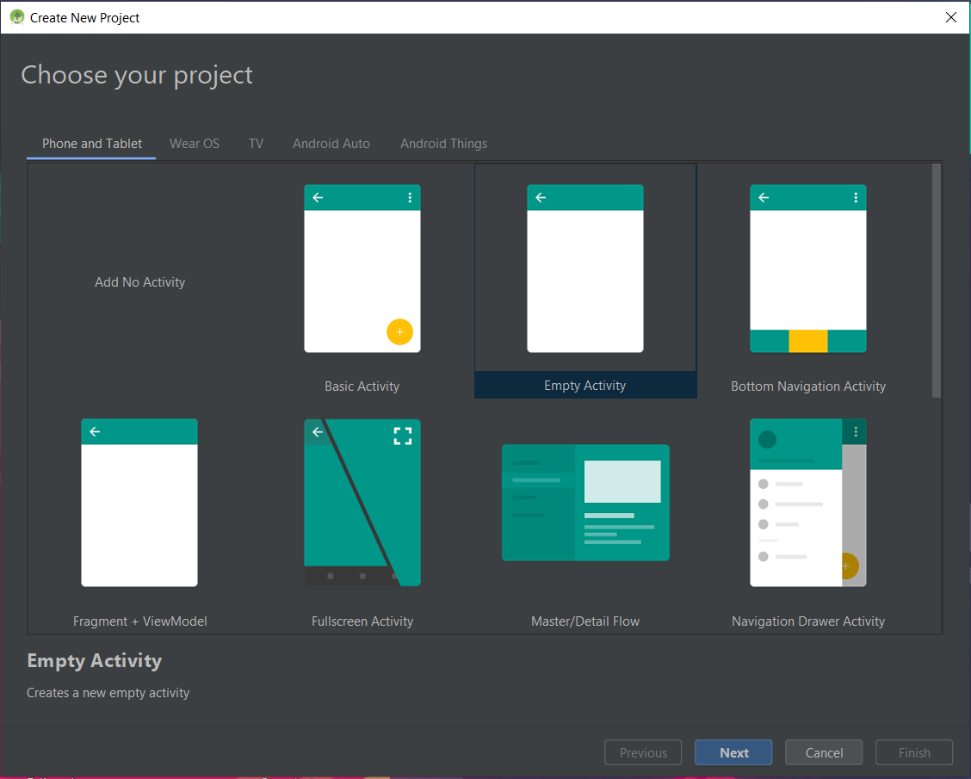](https://classroom.udacity.com/courses/ud808/lessons/4216368924/concepts/43001585890923)](https://classroom.udacity.com/courses/ud808/lessons/4216368924/concepts/43001585890923)

For this example, we chose the **“Empty Activity”** template. Enter the necessary project-specific information such as Project Name, Package, Location, and Language in the next window:

[[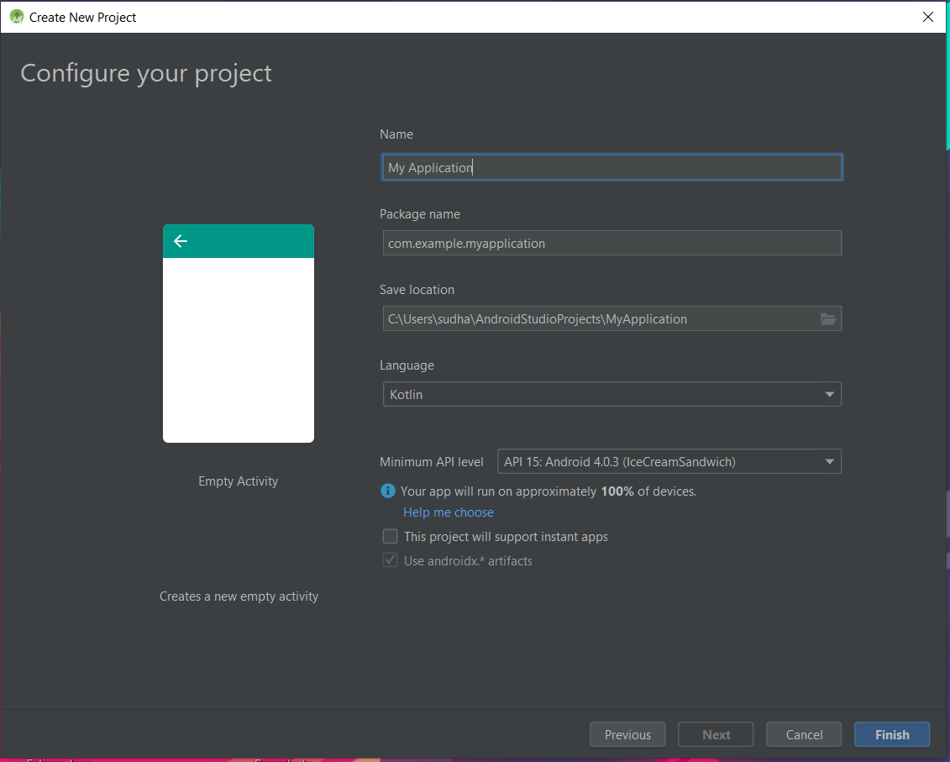](https://classroom.udacity.com/courses/ud808/lessons/4216368924/concepts/43001585890923)](https://classroom.udacity.com/courses/ud808/lessons/4216368924/concepts/43001585890923)

Following is the snapshot of the successfully installed IDE. You may choose to update the IDE and Plugins if prompted.

[[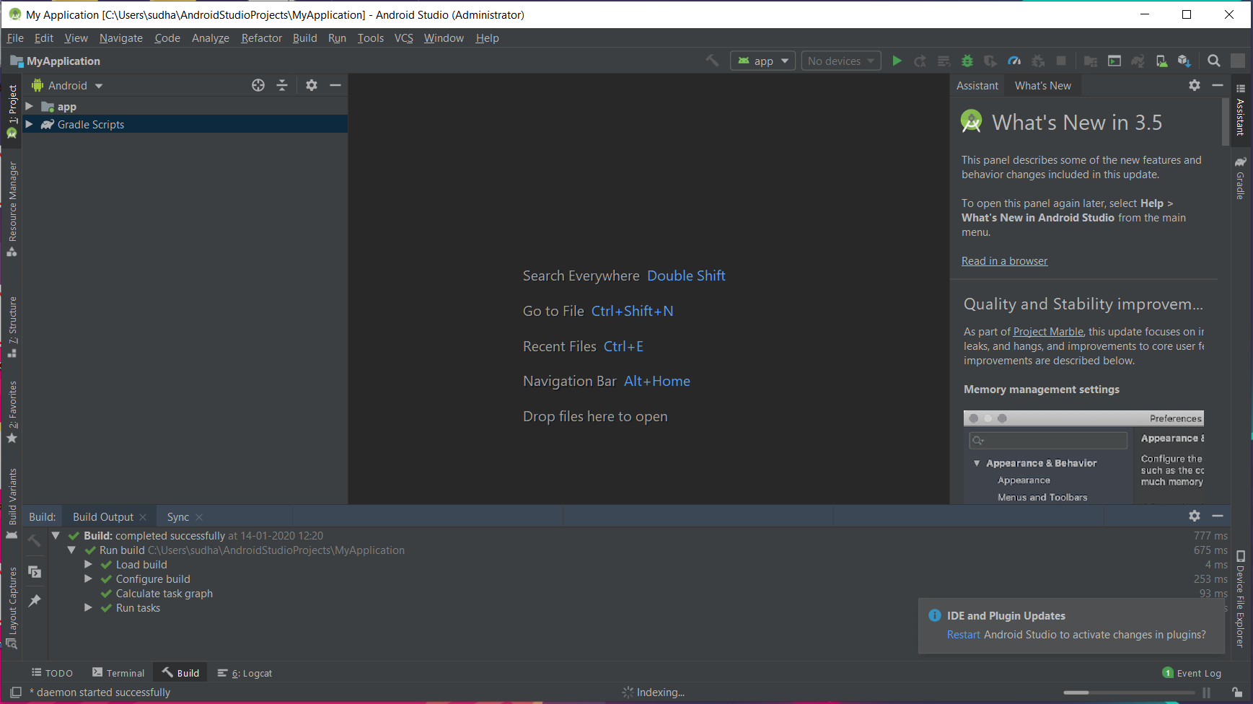](https://classroom.udacity.com/courses/ud808/lessons/4216368924/concepts/43001585890923)](https://classroom.udacity.com/courses/ud808/lessons/4216368924/concepts/43001585890923)

You are all set to develop Apps in Android Studio.